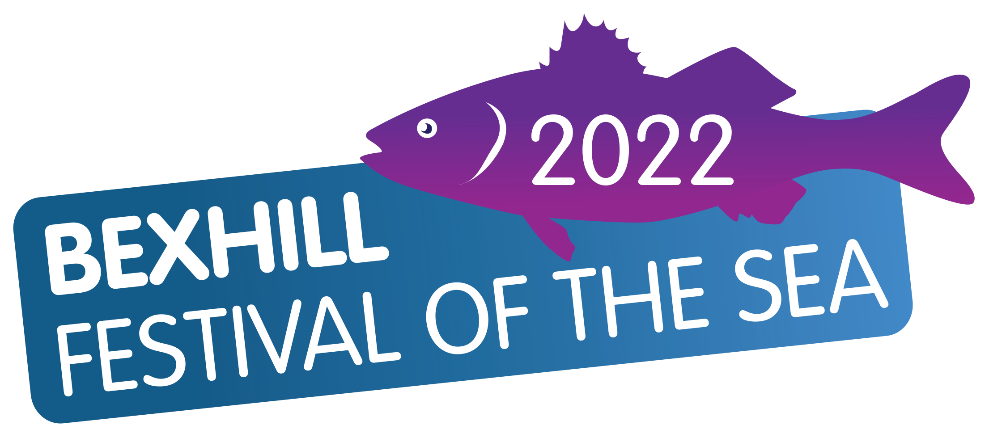

BASS CATCH AND RELEASE SPECIES HUNT
Sunday 18th September 2022 10am to 2pm
- All competitors to book in and pay prior to fishing and should sign out at Bexhill Sea Angling Club at Galley Hill before fishing. Advance booking please.
- Fishing will be from 10am to 2pm inclusive and all anglers must register their catch at Bexhill Sea Angling Club before 2.45pm.
- Fishing will take place between Galley Hill and Norman’s Bay, shore only.
- Anglers can fish with two rods to a maximum of three hooks with a lure counting as one hook. Any bait can be used.
- The competition will be fished on a photo recorded, catch and release species hunt (although competitors may retain their catch if it meets the legal requirements). The angler with the longest Bass will be the winner. There is no minimum qualifying length provided that all fish below legal retained size limits are returned to the sea alive.
- A match card will be issued at registration; the image of each photographed fish should be clear and must contain the match card within the photograph.
- Cameras may not be shared.
- To qualify the fish must be photographed beside the match card and with the nose of the fish accurately aligned with the zero mark and the tail closed and straight over the measure. Badly aligned fish will be disqualified. Qualifying fish must be measured on flat ground, ensuring that the measuring tape is not stretched along bent fish with the tape numbers clearly visible.
- Measures and tapes used must be available for inspection.
- Prizes will be awarded based on the length of the fish only.
- If no Bass are caught, then we will accept the longest fish of any other species for the prizes.

PLEASE ENSURE THAT NO LITTER IS LEFT ON THE BEACH.
Note:
All entries must be received by Wednesday 14th September 2022 please. Entries after this date will be accepted at the organiser’s discretion.

