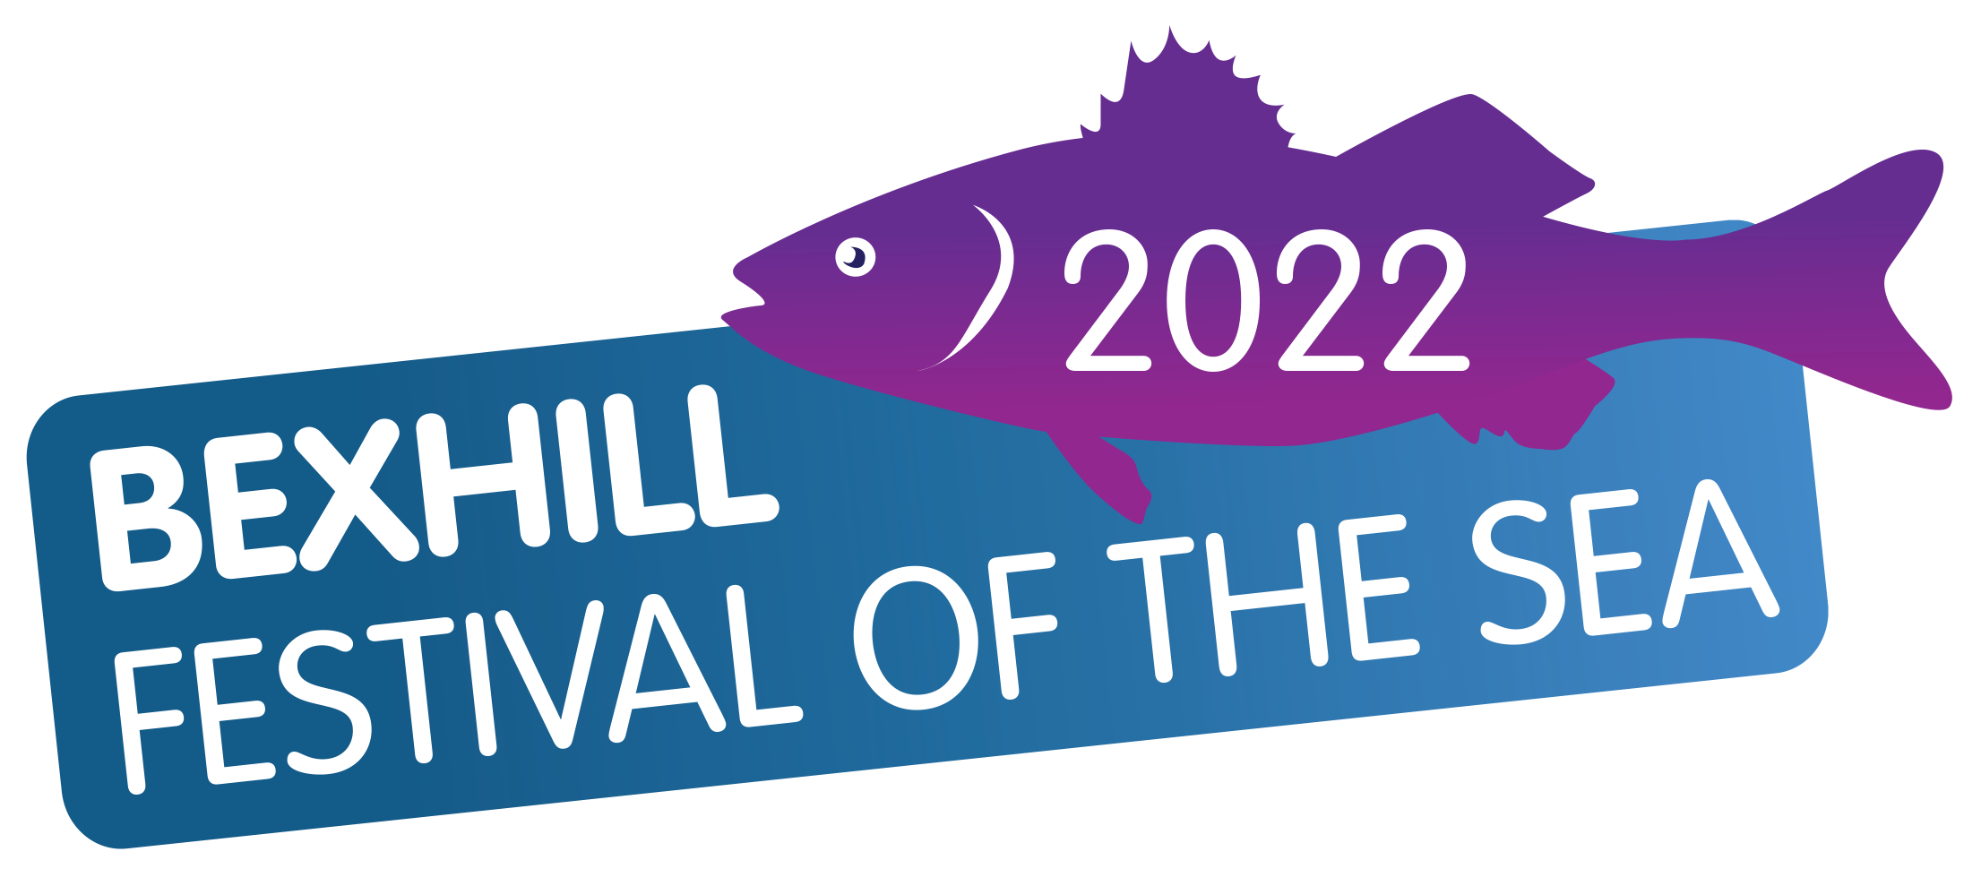
BEXHILL FESTIVAL OF THE SEA 2022
Angling Competitions from 5th to 25th September

Angling Competition Entry Form

Beach Specimen Hunt Entry £15 Yes/No £______
Monday 5^{h} September Start 9am to
Friday 9th September 5pm
(Photo - Catch & Release)
Pegged Open Beach Entry £20 Yes/No £______
Sunday 11th September (10am to 3pm)
Penn Points Match

Bass Specimen Hunt Entry £15 Yes/No £______
(Catch & Release)
Sunday 18th September (10 am – 2 pm)

Boat Species Hunt – FLATFISH ONLY Entry £15 Yes/No £______
Sunday 25th September (9am to 2pm)

Total enclosed £ _____________

Please print clearly in block capitals. See web site for competition rules. Junior (Under 18) Lady
Please complete and send with cheque made payable to Bexhill Festival of the Sea to:

Reeders, 16 Calvert Close, West Park, Uckfield, East Sussex , TN22 2BZ or deliver cash or cheque to Anglers Den.
Bank transfer details by request. Telephone: 01825-769240 or 07917-863175
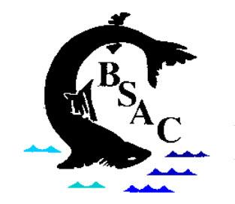
Name
Address
Town |  |  | Post Code
Telephone | Home: |  | Mobile:
Club/Association
(if applicable)
Email Address
I have read and retained the competition rules and agree to abide by them. I agree that the organisers shall not be held responsible for any loss, accident or damage to any competitor, official or member of the public.
Signed: _____________________________________________
Please tick box if you would like us to keep your information for future events. We respect your privacy and will not forward your information to any third party.

